Statistical Techniques
7MA505
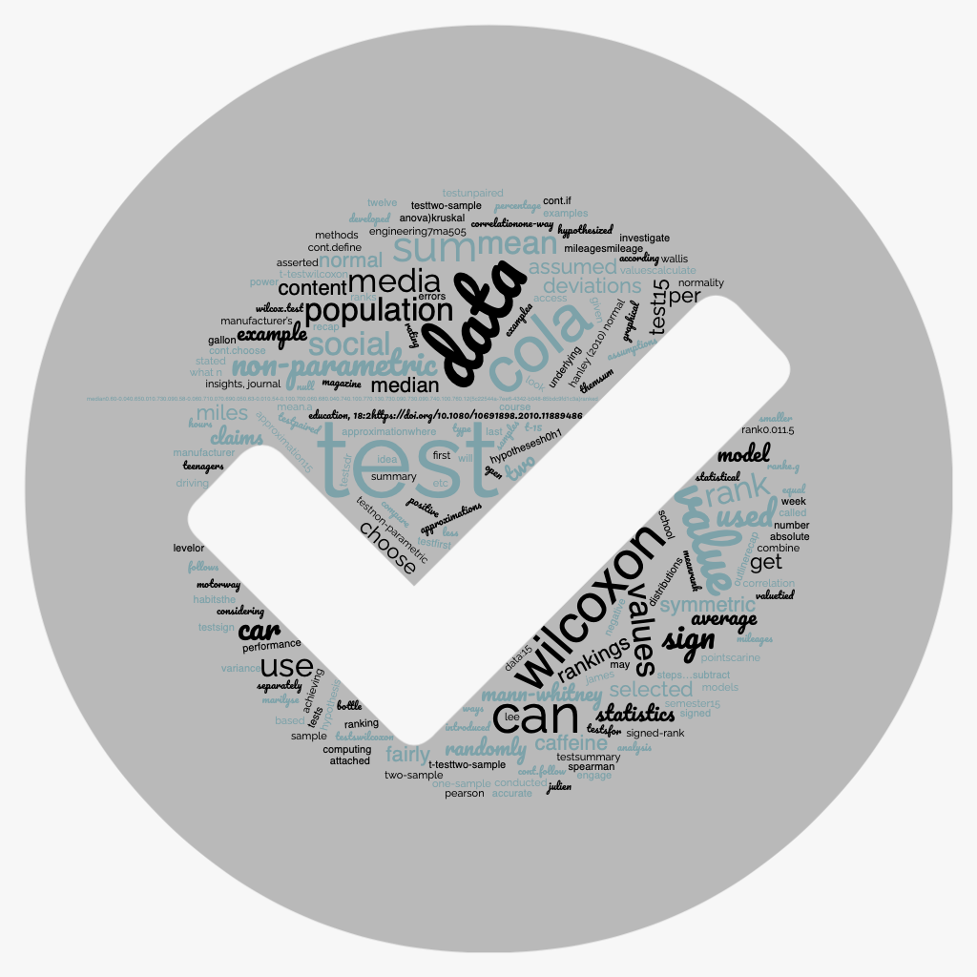

Assessment Brief: Portfolio
Dr. Petra Staynova
Dr. Alexandros Rompas

Statistical Techniques 7MA505
Contents
Module Leader 3
Key dates and details 3
Description of the assessment 3
Assessment Content 4
Assessment Rubric 4
Anonymous Marking 4
Assessment Regulations 5
Formative Assessment 5

Module Leader
Dr Lee Barnby
Email: l.barnby@derby.ac.uk
Phone: 01332 591747
Office: MS229 (office hour Thursday 11-12) also available on Teams chat
Dr Petra Staynova and
Email: P.Staynova@derby.ac.uk

Module Leader
Dr Alexandros Rompas
Email: a.rompas@mc-class.gr
Phone: + 30 210 8899664
Office: 504 (office hours Wednesday 15:00 – 16:00) also available on Teams (scheduled)

Key dates and details

Assessment Type: | Individual  Portfolio
Assessment weighting: | 100%
Word count/Length: | Typically, a report of several (~15) pages generated via markdown with figures, including a formatted executive summary at the beginning and a reflective section at the end. Equivalent effort to a 4500-word written report.
Learning Outcomes: | 1 and 2
Submission Method: | Blackboard Assignment
Submission Date: | 12 noon UK time, Thursday 15/1/2026  Other formative tasks will need to be prepared for tutorial sessions.
Provisional Feedback Release Date: | 12 noon UK time, Thursday 5/2/2025

Description of the assessment
The assessment will be by means of a portfolio of learning artefacts demonstrating the achievement of the learning outcomes. For equivalence, the assessment workload will equate to around 4500 words. Typically, this will consist of a small number of R Markdown documents in which you will present well documented examples or case studies where you correctly apply statistical techniques to one or more datasets of your choice. This should include an executive summary which includes the main findings and a reflection on how you have demonstrated the learning outcomes.
The learning outcomes themselves are
- Obtain a comprehensive understanding of statistical concepts and a critical awareness of their applications to real-life [engineering] problems, together with the ethical consequences.
- Develop comprehensive hypothesis testing and statistical analysis to investigate relevant complex problems.
The assessment is specified in this way, rather than in the style of a scientific report or paper, so that you can include elements from different datasets, such that you can demonstrate understanding of a broad range of statistical techniques.
If you wish to present your portfolio in a different way, then you must check with the module leader that this is appropriate.

Assessment Content
This section contains additional information on the content of the recommended portfolio components.

The executive report
The aim of the report is firstly to summarise the findings of the examples that you have submitted. You should clearly state what was being tested as well as the outcome. Mention the evidence for this but not the calculation itself, which should be shown in the markdown script. Include any assumptions made or how they were tested. Secondly you should reflect on how your portfolio achieves the learning outcomes. In total this should be around 3-4 pages long. You should use suitable markdown features for formatting this section. There is no need for a title page or table of contents for a document of this size. Any techniques introduced in the lectures or course materials do not need to be referenced. You should reference data sources and any more advanced techniques that you wish to adopt. The report is a summary so you shouldn’t find yourself explaining the techniques themselves. This section of the report may be checked for similarity.

The case studies
You will start by selecting some publicly available datasets which you will use to test hypotheses using the techniques that we will study. Although you can start to think about this early in the module it will inevitably be an iterative process as you learn more techniques and see how they are applied. Therefore, you will not necessarily be able to select a single dataset for which you demonstrate a large range of techniques. It may be simpler to use two or three examples. There will be the opportunity to discuss your datasets and the questions you might pose in tutorials for formative feedback.
It is recommended to use R to process and investigate your data. By using the R Markdown feature, you can produce annotated scripts which both explain what you are doing and show the results of calculations performed. It is possible to export the script output as a pdf or Word document, and this is what you should submit in addition to the script itself. The reason for this is to ensure that the document appears correctly to the person marking your work, without having to access the data or load additional libraries. The original script is submitted in addition to this exported version.
This section will not be checked using Turnitin because the R commands will inevitably generate a large matching score.
As a final reminder, when making the submission you should attach the pdf or Word document (i.e. the result of ‘knitting’ in R) and the markdown script (.rmd format). If students wish to use python, then the equivalents should be substituted.
 | Poor, unacceptable | Acceptable, quite good | Good, very good  indicated by [ ] | Exceptional
Demonstrate the use of key statistical concepts.  (30%) | Very limited (one or two) basic techniques shown.  (0-14) | Correct use of some of the techniques and concepts, tending towards a more basic selection.  (15-17) | A good range of techniques with [all] hypotheses correctly stated.  (18-23) | Range includes advanced techniques, or a more advanced concept is tackled.  (24-30)
Show ability to obtain and evaluate solutions.  (30%) | No correct work, no evaluation e.g. stating a statistical result (figure) without attaching any meaning.  (0-14) | Some problems with the questions posed or solutions obtained although some correct work is contained.  (15-17) | Numerically correct solutions to [more complex] problems with correct conclusions regarding the hypothesis.  (18-23) | Very good/exceptional in one of two ways:  Evaluation: relating the hypothesis back to the data.  Difficulty: e.g., dealing with missing data or non-linear aspects  (24-30)
Justify the choice and any assumptions.  (25%) | Some awareness of the need for assumptions but nothing implemented, no justification made.  (0-11) | Little or only superficial justifications given. Basic tests of assumptions.  (12-14) | Relating choice to form or type of data. Checking some [or most] of the relevant assumptions e.g., on normality  (15-19) | In depth checks on assumptions and consequences of what is found (or not). Justifying any choices between valid techniques.  (20-25)
Present work and ideas clearly.  (15%) | Information is missing or much too brief. Or  Work is confused with several conflicting instances.  (0-6) | Some supporting information is provided or there is more information, but it is occasionally confusing or conflicting.  (7-8) | Good standard, few [or no] issues with things missing or unclear.  (9-11) | Exceptional clarity of ideas, report of very good quality for figures, text and code.  (12-15)

The first column shows the assessment criteria and the relative weighting. The four columns show the range of marks available for each category in which that criterion is assessed. There will be more discussion on this in the live sessions.

Anonymous Marking
Submissions in Blackboard
You must submit your work using your student number to identify yourself, not your name. You must not use your name in the text of the work at any point. When you submit your work in Blackboard you must submit your student number within the assignment document and in the submission field.

Assessment Regulations
The University’s regulations, policies and procedures for students define the framework within which teaching, and assessment are conducted. Please make sure you are familiar with these regulations, policies, and procedures.

Formative Assessment
During the semester there will be some formative assessment tasks - meaning no marks are awarded. These assist in the process of selecting your own datasets and formulating the right questions to ask. It is important to participate in these assessments and it should be noted that no extensions can be applied to these tasks since they will involve working together with students in small groups. The benefit is that you can align your work with others in the cohort, for example getting the right degree of difficulty or appropriate amount of work.

This will be interpreted broadly to cover real-life examples from many fields of enquiry, not just engineering.

